- \Operation\Monitoring dust flap\Settings
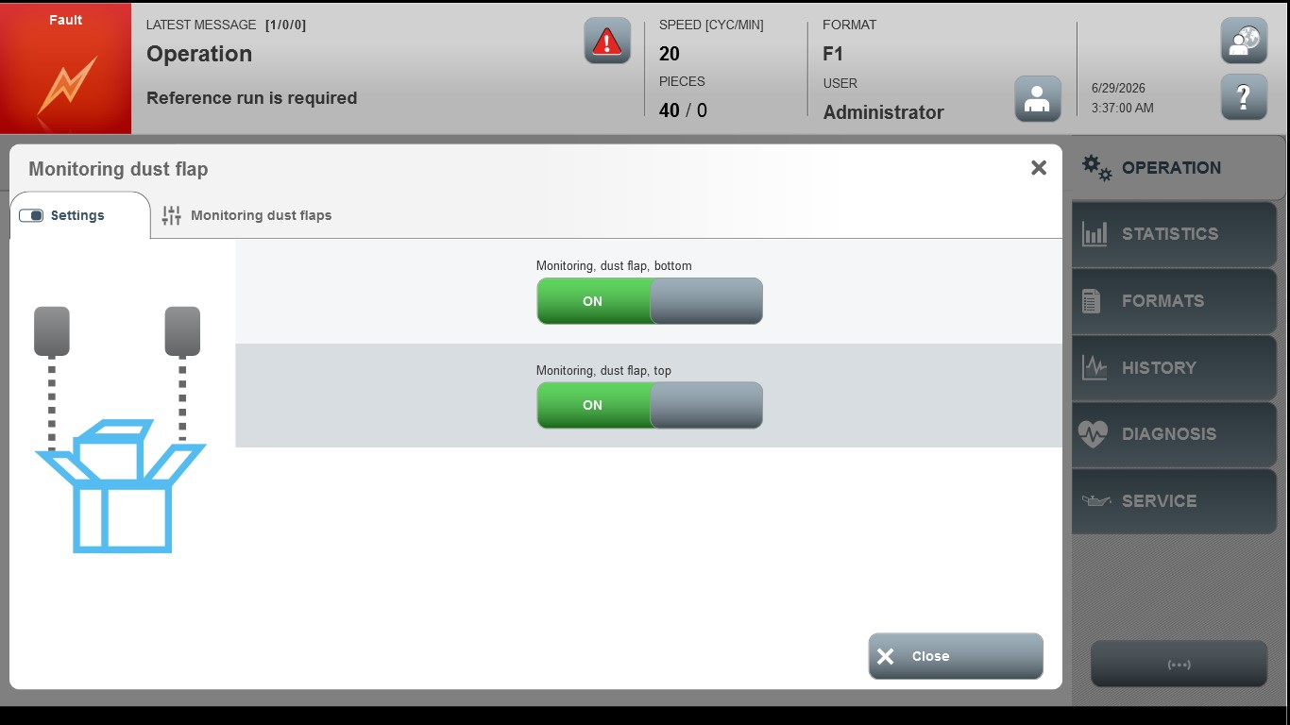
Acceptance criterion | Limits | Pass / Fail: Dev-No. | Date | Initials
Screen matches screenshot | N / A

